

Course Name/Code
DATA MINING (SEN431)
Course Instructor
Prof. Dr. ZAFER ASLAN
Group 17
Abdulmohaimin Bashir (B2205.010021)
Muhammad Bilal (B2105.010028)
Nusaibah Mekkaoui (B2205.010015)
Nasra Ali Noor (B2105.010003)

Contents
Introduction 3
Literature review 3
Methodology 4
Data Pre-Processing 4
Descriptive Statistics 5
Time Series Analysis 6
Clustering and Classification 7
Future Simulations 9
Conclusion 10
References 11

Introduction
Data mining is the process of analysing large datasets in order to find hidden patterns, correlations and anomalies with the help of statistical analysis and machine learning. The information found can be used to make informed decisions, predictive modelling, as well as understanding complex problems. While data mining falls under the umbrella of data analytics, its main point of focus is extracting the patterns and knowledge hidden within those datasets.
Generally, the process of data mining follows 10 steps. Firstly, one must describe the problem and explain how mining the data will address it. Secondly, data must be collected from a variety of sources and must correspond to the data needed to solve the problem. The this acquired data must be cleaned and pre-prepared. Then, basic statistical measures as well as visualization graphs and other exploratory data analysis are used to explore the data in order to gain an understanding of it. One must then select predictors in order to identify features the relevant in the dataset. This may involve removing redundant or irrelevant data. Next, a model or an algorithm must be selected suitable for the type of problem, data and output required. The next step is used to train the model using the previously pre-prepared data. The model’s performance and efficiency are then assessed using a validation set, after which it is deployed into a real-world environment to make predictions and classify new data. Finally, the model is monitored and maintained to ensure it remains valid and relevant.
The main problem we are trying to resolve using data mining is that we have a dataset containing wind speed, measured in Knots, over a time period of four years. This document aims to report the analysis of this data and portray the wind speed and direction in different forms using a variety of techniques such as clustering and classification, amongst others; such that it may help us understand the data and predict future wind patterns.

Literature review
Since wind energy is now considered a key element of the global drive for renewable energy sources, issues such as variability and inefficiency become important to address. These challenges, especially nonlinearity in wind behaviour, are resolved by machine learning and data mining to transform wind energy prediction. Among the DM techniques, the application of SCADA techniques that involve mining large datasets on wind flow, turbine alignment, and power generation factors have been key in unlocking value (Castellani et al., 2017). These two boost the performance of a turbine and its energy yield by revealing patterns that are not obvious, relations.

The subsequent assessments must be accurate, so data preprocessing can be considered as preliminary work. This comprises data cleaning over temporal data, normalisation of the wind speed data, and aggregating over the daily wind speed data for analysis. For example, the transformation of wind speed from the unit knots to meters per second and the daily accumulation of wind climate data have successfully prepared the datasets for predictive modelling. After data pre-processing and trend detection, other more complex analysis methods can use these insights for accurate predictions.
Long-term wind power forecasting has been done by machine learning algorithms like Random Forest, SVR and XGBoost which take historical wind speed data as input to predict future energy outputs (Demolli et al., 2019). These methods are good when dealing with large and non-linear distributions of data and can navigate changes in trends better than linear methods therefore are more consistent and accurate when forecasting. for time series, exponential methods including the Holt-Winters has also been adopted in order to help in the generation of the future pattern of the wind. For instance, the wind farms that integrated these methods have shown enhanced near-term wind power prediction and better system management.
Wind resource estimation and wind variability continue to be important as far as the reliability of the generated power and profitability of the investment are concerned. One of the major challenges of wind energy utilization is the variability of wind energy output, which can be solved by geographical aggregation of wind power generation and by using advanced methods of output prediction. These approaches minimize backup power demand and provide a stable means of incorporating wind power into the energy supply grid (Stetco et al., 2019). Further, methods such as time series analysis, and clustering also enhance the management of the turbines by giving details of the behaviour of the wind at a specific period. advise operators of the best arrangement of the turbine to capture as much energy as possible. For instance, clustering has been used in wind pattern classification to help operators change the wind turbine parameters in real time to gain maximum results.
Lastly, the combined use of the data mining and machine learning frameworks results in substantial development of wind energy prediction. Using the methods of clustering, classification, regression, and time series analysis, these technologies increase effectiveness, credibility, and capacity in the renewal energy systems. Starting with the methods to analyse the variance of SCADA and leading to methods to execute an exact prediction, the importance of machine learning and data mining stays undisputed to solve the variability of wind energy generation and promote the change to renewable energies on an international level.

Methodology

Data Pre-Processing
Data pre-processing included loading of the dataset, renaming of columns for clarity and dealing with temporal data. Below are the steps taken:
# Load the uploaded file to check its structure and content
file_path = '/content/Data Mining Project G17.xlsx'
excel_data = pd.ExcelFile(file_path)
sheet_names = excel_data.sheet_names

# Load data from Sheet1
data = excel_data.parse('Sheet1')

# Convert Year, Month, and Day columns back to integers for consistency
data[['Year', 'Month', 'Day']] = data[['Year', 'Month', 'Day']].astype(int)
data['Date'] = pd.to_datetime(data[['Year', 'Month', 'Day']])

# Rename the columns
data = data.rename(columns={'KAHRAMANMARAŞ_Direction': 'Direction', 'KAHRAMANMARAŞ_Speed': 'Speed'})

# Convert Wind Speed from Knots to m/s
data['Speed'] = data['Speed'] * 0.5144

# Drop Year, Month, Day as they are now redundant
data = data[['Date', 'Direction', 'Speed']]

# Re-check for missing values
missing_values = data.isnull().sum()
data.head(), missing_values
First 5 rows:
index | Date | Direction | Speed
0 | 2020-01-01 | 329 | 0.15432
1 | 2020-01-02 | 335 | 0.05144
2 | 2020-01-03 | 354 | 0.10288
3 | 2020-01-04 | 353 | 0.20576
4 | 2020-01-05 | 32 | 0.20576
Date | 0
Direction | 0
Speed | 0

The dataset had been made clean and ready for the analysis, and Date column was derived from the year, month, and day fields.

Descriptive Statistics
Descriptive statistics provided insights into the distribution and summary statistics of the wind speed and direction:
import matplotlib.pyplot as plt

# Descriptive statistics for wind speed and direction
descriptive_stats = data[['Direction', 'Speed']].describe()

# Plot wind speed distribution
plt.figure(figsize=(10, 6))
plt.hist(data['Speed'], bins=20, color='skyblue', edgecolor='black')
plt.title('Distribution of Wind Speed', fontsize=14)
plt.xlabel('Wind Speed (m/s)', fontsize=12)
plt.ylabel('Frequency', fontsize=12)
plt.grid(axis='y', alpha=0.75)
plt.show()

# Display the descriptive statistics
descriptive_stats
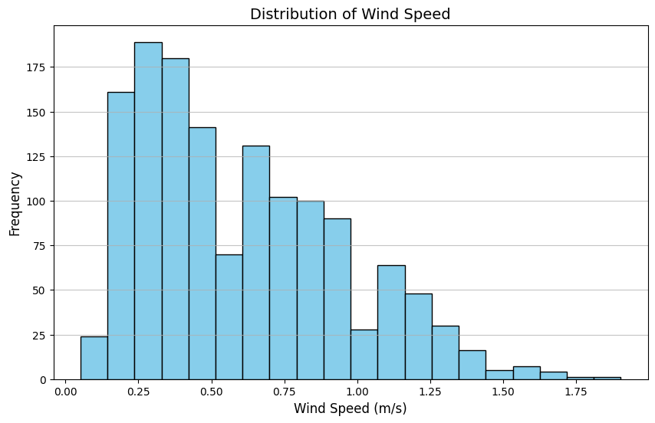
index | Direction | Speed
count | 1392.0 | 1392.0
mean | 220.41738505747125 | 0.605380804597701
std | 130.58981528320692 | 0.3459578372044025
min | 1.0 | 0.05144
25% | 53.0 | 0.30863999999999997
50% | 287.5 | 0.56584
75% | 324.0 | 0.82304
max | 360.0 | 1.90328
This step revealed the central tendencies and variability in the dataset, helping to identify patterns in the data.

Time Series Analysis
Time series analysis was conducted to observe daily wind speeds:
# Aggregate data by date to observe daily averages
daily_data = data.groupby('Date').mean()

# Plot time series of wind speed
plt.figure(figsize=(12, 6))
plt.plot(daily_data.index, daily_data['Speed'], label='Average Wind Speed', color='green')
plt.title('Time Series of Daily Average Wind Speed', fontsize=14)
plt.xlabel('Date', fontsize=12)
plt.ylabel('Wind Speed (m/s)', fontsize=12)
plt.legend()
plt.grid()
plt.show()
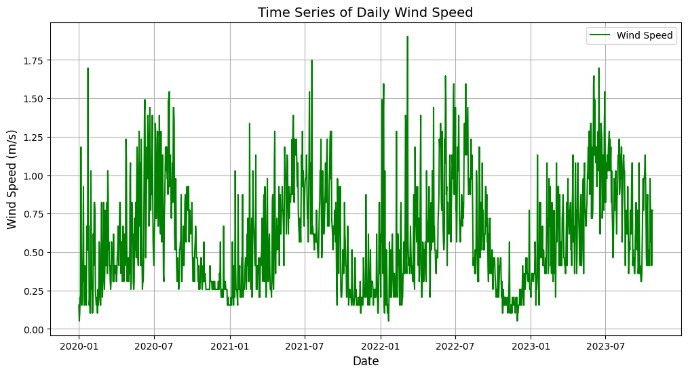
Date | Direction | Speed
2020-01-01 00:00:00 | 329.0 | 0.15431999999999998
2020-01-02 00:00:00 | 335.0 | 0.05144
2020-01-03 00:00:00 | 354.0 | 0.10288
2020-01-04 00:00:00 | 353.0 | 0.20576
2020-01-05 00:00:00 | 32.0 | 0.20576
With this method, we were able to see the historical trend and then use those to project the future wind speed in the later section.

Clustering and Classification
The dataset was clustered using the k-means algorithm along with Elbow method to determine the best k number, to identify patterns in wind speed and direction:
from sklearn.cluster import KMeans
from sklearn.preprocessing import MinMaxScaler

# Normalize data for Machine Learning
scaler = MinMaxScaler()
normalized_data = scaler.fit_transform(daily_data[['Direction', 'Speed']])
daily_data[['Norm_Direction', 'Norm_Speed']] = normalized_data

# Determine WCSS for different numbers of clusters
wcss = []
k_range = range(2, 11)

for k in k_range:
kmeans = KMeans(n_clusters=k, random_state=42)
kmeans.fit(normalized_data)
wcss.append(kmeans.inertia_)

# Plot the Elbow Method results
plt.figure(figsize=(8, 5))
plt.plot(k_range, wcss, marker='o', linestyle='-', color='b')
plt.title('Elbow Method for Optimal k', fontsize=14)
plt.xlabel('Number of Clusters (k)', fontsize=12)
plt.ylabel('WCSS', fontsize=12)
plt.xticks(k_range)
plt.grid()
plt.show()

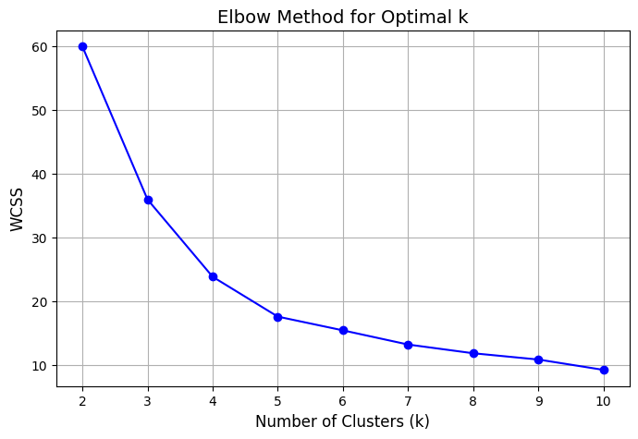

# After observing the elbow point, re-run k-means with the chosen k
optimal_k = 5
kmeans = KMeans(n_clusters=optimal_k, random_state=42)
data['Cluster'] = kmeans.fit_predict(normalized_data)

# Visualize clustering results for optimal k
plt.figure(figsize=(10, 6))
for cluster in range(optimal_k):
cluster_data = data[data['Cluster'] == cluster]
plt.scatter(cluster_data['Direction'], cluster_data['Speed'], label=f'Cluster {cluster}')

plt.title('Wind Patterns Clustering with Optimal k = 5', fontsize=14)
plt.xlabel('Wind Direction (Degrees)', fontsize=12)
plt.ylabel('Wind Speed (m/s)', fontsize=12)
plt.legend()
plt.grid()
plt.show()

# Summary of cluster counts
print(data['Cluster'].value_counts())
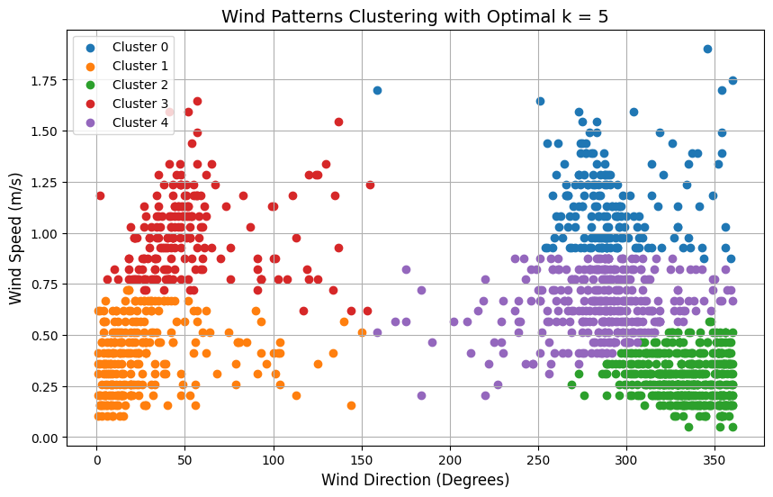
index | Cluster
2 | 419
4 | 346
1 | 257
3 | 196
0 | 174
Distinct wind patterns were revealed in clusters, and served to classify further and for analysis.

Future Simulations
The objective of this simulation was to generate actionable insights to planning and resource management with available historical data for predicting future trends.
Forecasting future wind speeds using 120 days and the wind speed patterns were predicted by using exponential smoothing techniques:
from statsmodels.tsa.holtwinters import ExponentialSmoothing

train_data = daily_data['Speed'][:-120].astype(float) # Train all but the last 120 days
test_data = daily_data['Speed'][-120:].astype(float) # Test the last 120 days

model = ExponentialSmoothing(train_data, trend='add', seasonal='add', seasonal_periods=365, damped_trend=True)
fitted_model = model.fit()

# Forecast the next 120 days
forecast = fitted_model.forecast(120)

plt.figure(figsize=(12, 6))
plt.plot(daily_data.index, daily_data['Speed'], label='Observed', color='blue')
plt.plot(forecast.index, forecast, label='Forecasted', color='orange', linestyle='--')
plt.axvline(train_data.index[-1], color='red', linestyle='--', label='Forecast Start')
plt.title('Wind Speed Forecast', fontsize=14)
plt.xlabel('Date', fontsize=12)
plt.ylabel('Wind Speed (m/s)', fontsize=12)
plt.legend()
plt.grid()
plt.show()

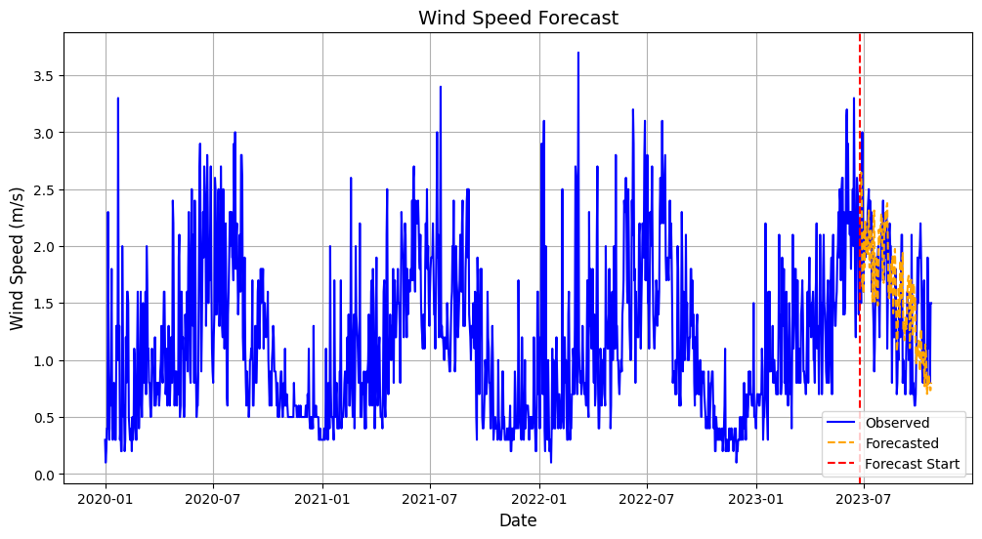

Conclusion
As mentioned previously, data mining is the process of analyzing large datasets with the purpose of finding hidden patterns and correlations using machine learning and statistical analysis where the information gained can be used to understand complex problems, make informed decisions and predictive modelling. This process is achieved by following ten critical steps starting with defining the problem, collecting data, pre-preparing it, exploring it, selecting predictors, selecting a suitable model, training the model and validating it, then deploying the model, and, finally, monitoring and maintaining the model.
Data mining is useful when applied on renewable energy sources such as wind energy. Although wind energy is a formidable renewable energy source, it doesn’t come without its vulnerabilities which include variability and inefficiency. Data mining techniques such as SCADA improve a turbine’s energy output using the patterns discovered with machine learning. This is where the 10 steps of the data mining process come in. The data harvested from the large wind speed datasets must be preprocessed and cleaned before we can start making any predictive models. Wind power forecasting can be made using algorithms such as the Random Forest or SVR especially since they are good at navigating changes in trends and can deal with non-linear distributions and large data. Predictive models resulting from the data analysis of winds speeds along with time series analysis can be helpful in minimizing the backup power needed in order to provide a stable amount of wind power to energy supply grids as well as improving the management of the turbines during certain times. Clustering helps us get this is done by changing wind turbine parameters in real time.
To sum things up, data mining helps us understand and navigate data regarding wind speed over periods of time through methods such descriptive analysis, classification, clustering, as well as time series analysis. Working hand-in-hand with data mining we can gain a better understanding of wind speed forecasts to improve and maximize efficiency of wind turbines.

References
Castellani, F., Astolfi, D., Sdringola, P., Proietti, S., & Terzi, L. (2017). Analyzing wind turbine directional behavior: SCADA data mining techniques for efficiency and power assessment. Applied Energy, 185, 1076–1086. https://doi.org/10.1016/j.apenergy.2015.12.049
Demolli, H., Dokuz, A. S., Ecemis, A., & Gokcek, M. (2019). Wind power forecasting based on daily wind speed data using machine learning algorithms. Energy Conversion and Management, 198, 111823. https://doi.org/10.1016/j.enconman.2019.111823
Stetco, A., Dinmohammadi, F., Zhao, X., Robu, V., Flynn, D., Barnes, M., Keane, J., & Nenadic, G. (2019). Machine learning methods for wind turbine condition monitoring: A review. Renewable Energy, 133, 620–635. https://doi.org/10.1016/j.renene.2018.10.047
What is data mining? Key Techniques & Examples. Qlik. (n.d.). https://www.qlik.com/us/data-analytics/data-mining#:~:text=Data%20mining%20is%20the%20process,modeling%2C%20and%20understanding%20complex%20phenomena

