ISTANBUL AYDIN UNIVERSITY

Engineering Faculty
Computer Engineering

SEN431 - Data Mining
Prof. Dr. Zafer ASLAN

Buse Yüksek – B2005.010049
Gözde Civcik – B2105.010124
Sinem Çelik – B2005.010055
Semih Umuç – B2005.010072

Table Of Contents
Abstract 3
1. Introduction 3
1.1. Problem Statement 3
1.2. Wind Energy 4
1.3. Wind Speed in Manavgat 4
1.4. Aim of the Report 4
2. Literature Review 5
3. Methodology 8
3.1. Data Preprocessing 8
3.2. Descriptive Statics 15
3.3. Time Series Analyses 15
3.4. Classification 18
3.5. Clustering 19
3.6. Future Simulation With ANN 20
4. Conclusion 23
5. References 24

Abstract
Renewable energy has become an important solution to meet the increasing global energy demand and sustainability needs. Among renewable resources, wind energy is one of the most viable and environmentally friendly options. This report focuses on assessing the wind energy potential of Manavgat district in Antalya province, Turkey.
Using wind speed data from 2020, this study aims to assess the wind energy generation potential of Manavgat. Statistical analyses are conducted to understand the feasibility of utilizing wind power. The findings of this report will provide insight into the renewable energy generation capacity of the region and the future development of wind energy projects in Manavgat.

Introduction
An important pillar for climate change mitigation as well as achieving sustainable development is renewable energy. Out of the various renewable sources of energy, wind energy has emerged as one of the utmost areas owing to its cost-effective and clean utilization. Wind energy has, in the past few years, become apparent in developing and developed countries as a suitable replacement for fossil fuels. This research examines the feasibility of wind energy in Manavgat, which is in the Antalya province of Turkey. Manavgat has a great potential in renewable energy sources due to its climatic conditions and availability of diverse natural resources.

Problem Statement
The transition to renewable energy is essential for sustainable development. However, the efficient use of wind energy depends on detailed analysis of local wind conditions. Manavgat, located in the Antalya province of Turkey, is recognized for its natural resources and diverse climatic conditions. Despite its strategic location and exposure to seasonal winds, the region’s wind energy potential remains largely unexplored. The lack of localized wind speed analysis creates uncertainties about the feasibility of implementing wind energy projects in the area. This gap in research hinders the ability to evaluate whether Manavgat can contribute to Turkey’s renewable energy targets and overall energy security.

Wind Energy
Wind energy has emerged as a key renewable energy source, driven by the global need to reduce carbon emissions and address the increasing demand for electricity. This sustainable and environmentally friendly energy form is harnessed through wind turbines, which are critical components of any wind energy system. Wind turbines capture the kinetic energy of the wind and convert it into mechanical power, which can be used directly for various applications or further transformed into electrical energy. This conversion process typically relies on electromagnetic generators, which enable the efficient production of electricity. By utilizing the abundant and renewable resource of wind, wind energy systems contribute significantly to a cleaner, more sustainable energy future. (Abu Danish Aiman Bin Abu Sofian, 2023) (Enas Taha Sayed, 2023)
Globally, regions with wind speeds exceeding 5 m/s are considered highly suitable for wind energy generation, highlighting the importance of region-specific assessments to maximize efficiency and output. By leveraging these advancements and favorable conditions, wind energy systems contribute significantly to a cleaner, more sustainable energy future.

Wind Speed in Manavgat
Manavgat’s geographical characteristics, including its coastal proximity and varied terrain, make it a promising candidate for wind energy exploration. Initial observations suggest that the region experiences consistent wind patterns, particularly during certain seasons. However, comprehensive statistical analyses of wind speed data are required to confirm its suitability for large-scale wind energy projects. Data collected from 2020 onwards offers a valuable opportunity to evaluate the region’s wind conditions in detail.

Aim of the Report
This report aims to assess the wind energy potential of Manavgat by analyzing wind speed data collected from 2020 to the present. The specific objectives are as follows:
1. To analyze statistical properties of wind speed data, including averages, variability, and extreme events.
2. To estimate potential energy outputs from wind turbines based on local wind conditions.
3. To identify trends and provide recommendations for the development of wind energy projects in the region.

Literature Review
Wind energy represents a type of renewable energy that captures the kinetic energy produced by moving air to generate electricity. This process utilizes wind turbines, which transform the kinetic energy of the wind into mechanical energy, and then into electrical energy. As wind passes over the turbine blades, it generates lift, resulting in the rotation of the blades. These blades are linked to a drive shaft that rotates a generator, thereby producing electricity. Wind energy consumption is crucial to investigate because of wind’s enormous potential. Furthermore, wind turbine technology has advanced significantly in recent years. Turbines’ efficiency and reliability have increased, allowing them to produce more power. Moreover, wind turbines are also relatively safe to operate and have much lower environmental impacts than other power plants. Such an increase in efficiency will reduce the used areas, meaning that more land might be used for purposes other than turbines, such as farming or forestry. In various places, wind energy is extremely important since it helps meet many of the demands and problems these places encounter. Lowering dependency on distant power networks and boosting energy security provide a route toward energy independence. A clean and sustainable energy source, wind power assists communities in lowering their carbon footprint and promoting environmental sustainability. Wind energy ranks among the most favored types of renewable energy. It is presently regarded as one of the most sustainable substitutes for fossil fuels due to its minimal or nonexistent greenhouse gas emissions and its compatibility with environmental preservation. The world has two key goals by 2050: sustainable economic growth and carbon neutrality. According to the Global Wind Energy Outlook, adopting low-carbon electricity generation techniques can help achieve the goal, as the power industry emits 40 % CO2. So that, wind energy sources are gaining popularity worldwide because of their positive impact on environmental quality.
Wind power has been utilized for various applications, such as milling grains, pumping water, and sawing wood, for many years. Wind energy may be harnessed using two distinct types of wind turbines, depending on the direction of the revolving shaft. Wind turbine efficiency is the electrical power obtained by the wind turbine over the available power in the wind. (Li,2024). According to Albert Betz, obtaining more than 59.3% efficiency, theoretical, is unattainable, and the actual efficiency ranges between 25 and 45%. Another field for wind energy to use is buildings. Wind energy systems for buildings can potentially deliver 10%–20% of the energy requirements of tall buildings in an urban environment. Nearly 90% of urban wind energy systems are wind turbines. They can be deployed on buildings or ground next to buildings where high wind regimes are locally created, and these turbines mostly range from 1–20 kW. (Kwok K.C.S., 2023)Building design and aerodynamic devices can play a vital role in directing and increasing the wind flow to a suitable level for energy production. Therefore, investigations have focused on the impact of building design strategies for wind energy systems and their placement to maximize wind energy generation performance (Kwok K.C.S., 2023). Different types of wind energy systems and designs are currently available, including horizontal-axis wind turbines, vertical-axis wind turbines, power windows, and wind-induced vibration-based energy harvesters. Typically, efficient and high-performance designs are influenced by several design criteria, mainly related to the application to be served and the location where the system is to be installed (Kwok K.C.S., 2023). The process of creating the ideal flow for power generation is to improve the size and uniformity of velocity and reduce severe turbulence and disruption. In 2021, the largest share of wind power in the European Union was generated by Denmark (44%), followed by Portugal (26%), Spain (24%), and Germany (23%). Countries where these values ranged from 20% to 10% include Sweden (19%), Greece (18%), the Netherlands (15%), Belgium (13%), Croatia, Austria. (Wolniak, 2023)
Numerous studies have identified wind energy as one of the cleanest, infinitely sustainable, and ecologically advantageous renewable technologies currently available. The significant increase in wind turbine density has intensified the wake interactions between turbines, which has led to new challenges for the wind industry, especially in the farm planning stage, such as wake prediction, wake identification, and wind turbine performance analysis (Fan Z., 2023) The wake identification accuracy also influences the assessment of the local environmental impact by affecting the change in the atmospheric boundary layer. (Fan Z., 2023)The effects of wind turbines on local-to-mesoscale climates was overestimated, while the robust statistical signature of wakes were only observed at relatively short downwind distances (Fan Z., 2023)Wakes significantly affect the propagation of wind turbine noise because of the refraction that occurs when acoustic waves enter the wake domain, especially in the far field It is regarded as the most harmonious energy source for both humans and wildlife. However, some experts have noted minor environmental impacts, particularly concerning animal life. The establishment of wind farms necessitates extensive land areas with sufficient wind resources for optimal operation, which inevitably affects the local environment; nonetheless, the land beneath each turbine can still be utilized for livestock grazing or agricultural purposes. Additionally, wind farms have a direct effect on bird and bat populations, with birds being among the most frequent casualties of wind turbine incidents. It is essential to assess the implications of wind turbine operations and wind farms; however, when considering the overall benefits, wind energy has proven to be more advantageous than detrimental to the environment. The adoption of wind energy will significantly reduce or eliminate the reliance on fossil fuels, which are responsible for harmful emissions of CO2, NOx, and SOx, contributing to acid rain and global warming, ultimately leading to the greenhouse effect, rising sea levels, and erratic weather patterns.
Even though wind energy in the general sense is perceived positively as a clean source of energy generation, a variety of responses from the public can be observed. Research on public responses to WEP have typically examined acceptance dimensions like support and opposition. (Karakislak, 2021) Citizens can reject or accept the difference made by wind energy. The concept of social norms and their impact on how people react to unfamiliar changes in their environment provides a promising layer to understanding public responses. One of the most significant social benefits of wind power expansion is the creation of job opportunities; the rapid growth that the wind energy sector has shown in recent years is promising; according to the Office of Energy Efficiency and Renewable Energy, the field of wind energy employed over 100,000 people in the United States in 2016. Furthermore, wind farms can meet citizens’ demands, allowing them to carry out their activities without fear of blackouts
Energy is the main issue for industrial and economic improvement in a country. Worldwide, energy policymakers move to renewable energy resources to decrease CO2 emissions. The total renewable energy capacity, over the world, in 2019 was 2,536,853 MW; twenty-five percent is generated by wind energy because of the fast development in technology and its stable price.
Wind energy represents a vital component of the global transition to sustainable energy. While challenges such as intermittency and environmental concerns exist, ongoing advancements in technology and policy support are paving the way for a cleaner, more resilient energy future. By continuing to invest in wind energy, we can reduce carbon emissions, enhance energy security, and create a more sustainable world. Offshore wind energy provides a promising option for substituting conventional energies due to its low greenhouse gas emissions, cost-effectiveness, and abundant wind resources at seas. (Olabi, 2023) e goal is to develop 28 techno-climatic wind energy expansion scenarios, considering installed capacity expansion paths and potential wind farm sites to estimate the national and global wind energy yield in 2025–2054. Thirty-three countries have either installed offshore wind energy capacities or have concrete plans to install wind turbines by 2030. Data on existing, planned, or potential wind farm sites were collected as point or polygon data and aggregated. While some countries, like those in Europe, have designated specific zones for offshore wind energy, others, such as Brazil and Japan, are still assessing areas within their EEZs.
Wind energy is very important for our World. If humans want to live in a beautiful and healthy World we have to learn have to get energy sources in the right way. Wind energy is one of them and may be the cleaner way to reduce energy. Even though it has some challenges, we should keep our investments in wind energy so that we can lower carbon emission, and we will make a sustainable future world for mankind.

Methodology

Data Preprocessing
Linear interpolation is a mathematical technique used to estimate a value within a known range of data points. It assumes that the change between two consecutive points follows a straight-line relationship.
The process involves finding a proportional value between two known points, based on the position of the target value relative to the range. The formula for linear interpolation uses the slope of the line connecting the two points to calculate the unknown value.
Formula:
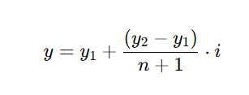
The formula provided can be used in Excel to perform interpolation calculations.
It is written as:
= Y1 + (Y2 - Y1) * (ROW(X) - ROW(X1)) / (ROW(X2) - ROW(X1))
- Y1 and Y2 are the known values corresponding to X1 and X2.
- X1 and X2 are the reference X-values.
- X is the variable X for which we want to calculate the interpolated Y-value.

Problem:
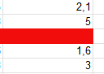
,

Known Values:
- y1​=1.6: Lower value
- y2=5: Upper value
- n=1: Number of missing values
- i=1: Position of the missing value (first and only one)

Calculation:
To calculate the missing value:
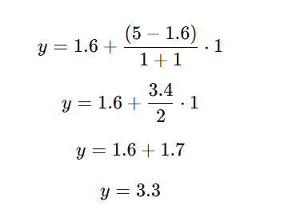

Result:
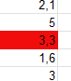

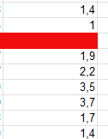
Problem 2:

Known Values:
- y1​=1.9: Lower value
- y2=1: Upper value
- n=1: Number of missing values
- i=1: Position of the missing value (first and only one)
Calculation:
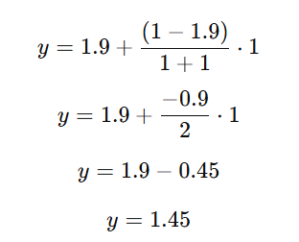

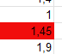
Result:

Problem 3:
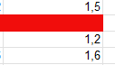

Known Values:
- y1​=1.2: Lower value
- y2=1.5: Upper value
- n=1: Number of missing values
- i=1: Position of the missing value (first and only one)
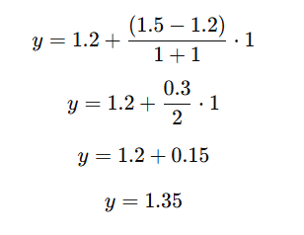
Calculation:

Result:
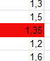

Problem 4:
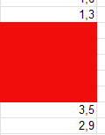

Known Values:
- y1​=1.3: Lower value
- y2=3.5: Upper value
- n=5: Number of missing values
- i=1,2,3,4,5: Position of each missing value

Calculation:
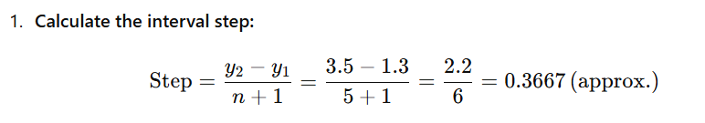

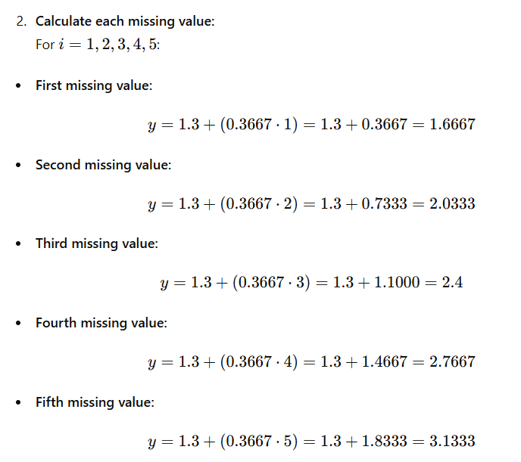

Excel Formula:

Result:
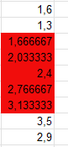

Problem4:
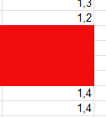

Known Values:
- y1​=1.2 (lower value)
- y2​=1.4 (upper value)
- n=4 (number of missing values)
- i=1,2,3,4 (position of each missing value)
Calculation:
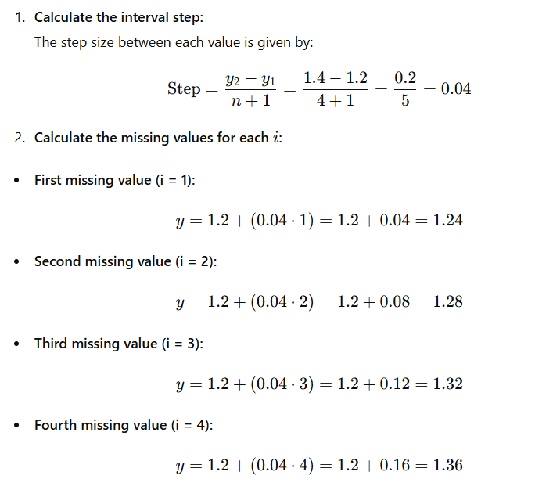

Excel Formula:

Result:
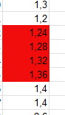

Problem 5:
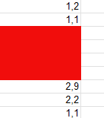

Known Values:
- y1​=1.1 (lower value)
- y2​=2.9 (upper value)
- n=4 (number of missing values)
- i=1,2,3,4 (position of each missing value)

Calculation:
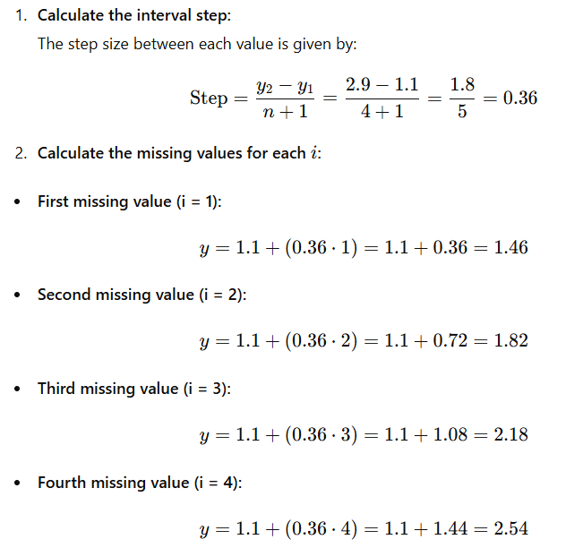

Excel Formula:

Result:
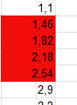

Descriptive Statics
By using Excel formulas, we calculated the Descriptive Statistics for our dataset. These statistics provide a summary of the data's central tendency, variability, and overall distribution. We applied Excel’s built-in functions such as AVERAGE, MEDIAN, MODE, STDEV, and others to determine key values like the mean, standard deviation, range, and more.
For our dataset our first data values is AE3 and the last one is AE1394.
Formula:
=AVERAGE(AE3:AE1394)
=MEDIAN(AE3:AE1394)
=MODE.SNGL(AE3:AE1394)
=MAX(AE3:AE1394)
=MIN(AE3:AE1394)
=STDEV.P(AE3:AE1394)
=VAR.P(AE3:AE1394)
Result:
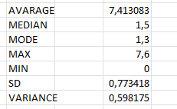

Time Series Analyses
In the given dataset, we have daily wind speed values for Manavgat from 2020 to 2023. To analyze these values over time, we can create several types of tables that group the data in different ways.
The first approach is to organize the data by year. In this case, we can summarize the wind speed values for each year, creating tables that show the daily wind speed for each individual year.

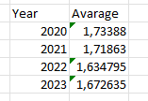

As a second approach, we calculated the monthly average wind speed for each year and organized the data into tables. By grouping the data by month, we were able to analyze the changes in wind speed on a monthly basis for each year.

Below, you can see the graphs that represent the monthly average wind speed changes for each year.

2020

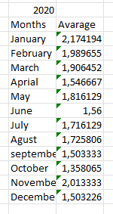

2021
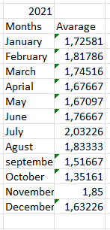

2022
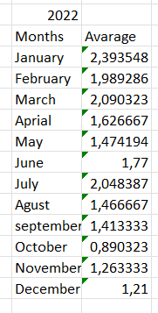

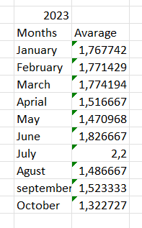
2023

Classification
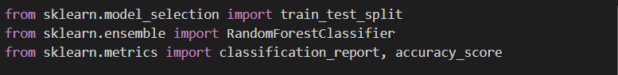
Classification is a machine learning method that aims to sort data into predetermined categories.
Figure 1.1
As we can see in Figure 1.1, the data is separated into test and training data and then libraries are used to define RandomForestClassifier and metric calculations.
Figure 1.2
“MANAVGAT_Speed” data is created as target variable. This variable will classify according to whether the speed is greater than 2 m/s or not. (Figure 1.2)
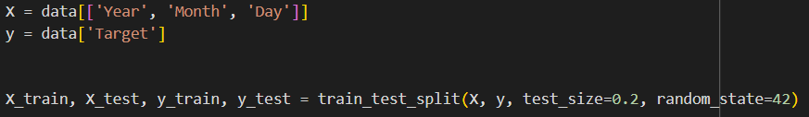
Figure 1.3
We defined our features and target data. Then we determined our test and training data by 20 to 80 percent. (Figure 1.3)

Figure 1.4
We created our model thanks to our libraries. We trained our model using RandomForestClassifier and our training data that we determined 80 percent. (Figure 1.4)

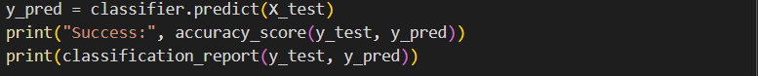
Figure 1.5
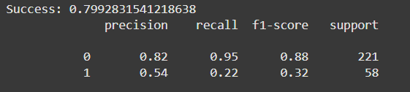
Finally, we do the prediction and evaluation. (Figure 1.5) In the picture you see below, there are also ratios. We see the results of metrics such as precision, recall and F1-score. (Figure 1.6)
Figure 1.6

Clustering
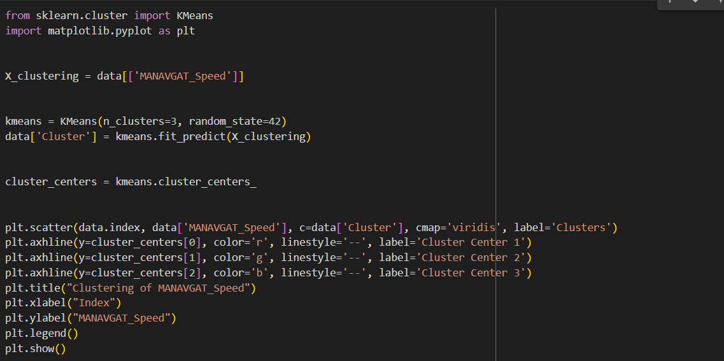
Clustering is one of the unsupervised learning methods and its purpose is to group or cluster data with similar characteristics.
Figure 2.1
Clustering was performed using “MANAVGAT_Speed” data. K-Means Clustering algorithm was used. This algorithm divides the data into a certain number of groups depending on the n_clusters parameter. We clustered the data into 3 different clusters. (Figure 2.1)
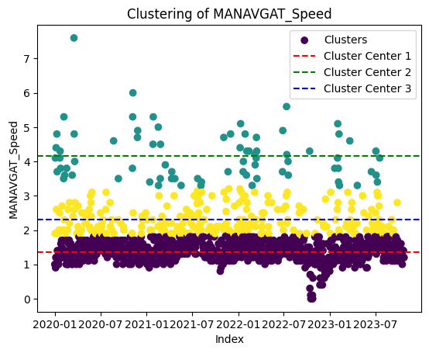

Figure 2.2
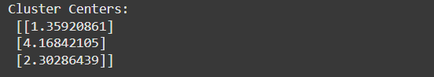
In the picture above, we see the visualization of the clustering of the data. (Figure 2.2) We can also examine the data points according to which the clusters are formed from the image below. (Figure 2.3)
Figure 2.3

Future Simulation With ANN
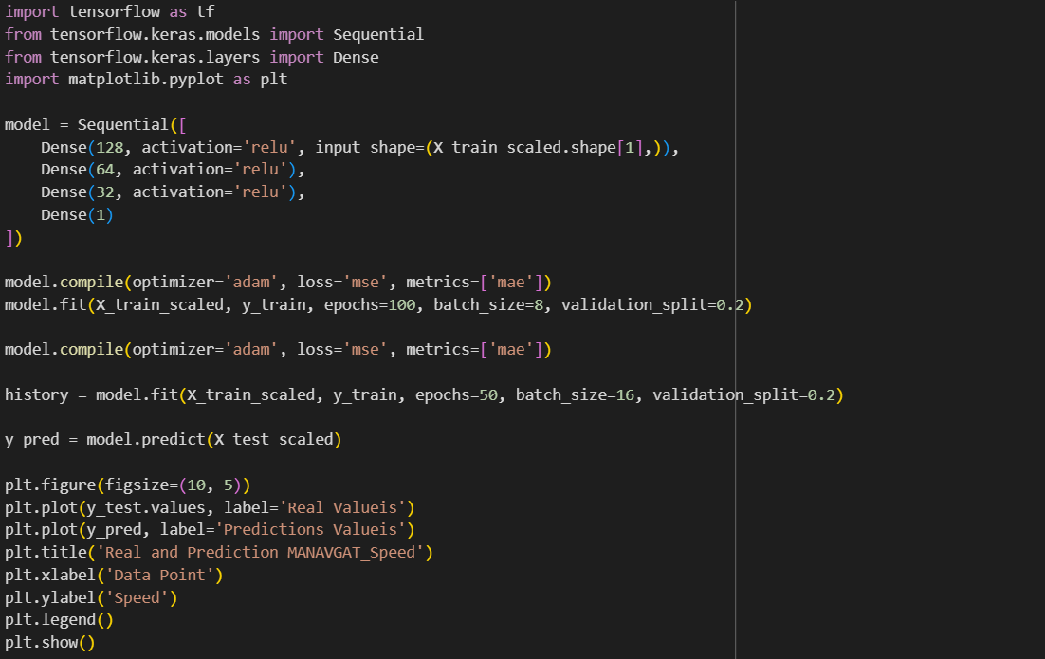
Figure 3.1
The model consists of three hidden layers with Sequential structure. Activation functions are used to increase the learning capacity of the network and to model non-linear relationships. These layers have reLu activation functions. Thanks to the Adam optimization algorithm, we automatically adjust the learning speed so that the model learns faster and more accurately. During the training process of the model, 100 epochs were set for the model to generalize better due to overfitting and underfitting. Then another 50 epochs were added, so that the model could learn the patterns in the data sufficiently and improve its accuracy. “MSE” and “MAE” were used to measure the performance and accuracy of the model. (Figure 3.1). Finally, the results are visualized. (Figure 3.2)

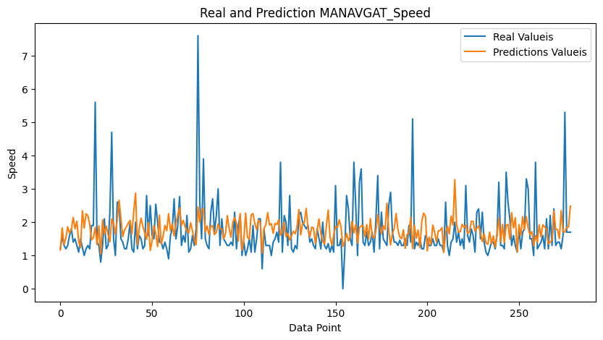
Figure 3.2
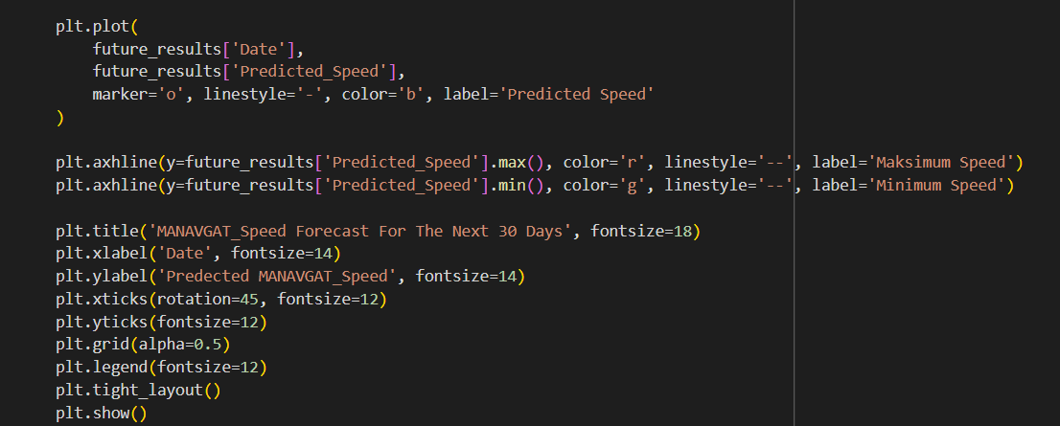
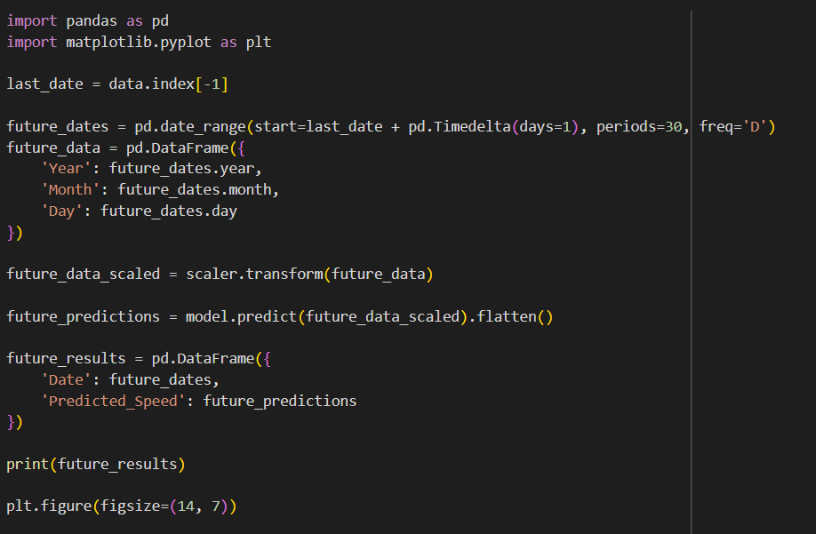
Figure 3.3
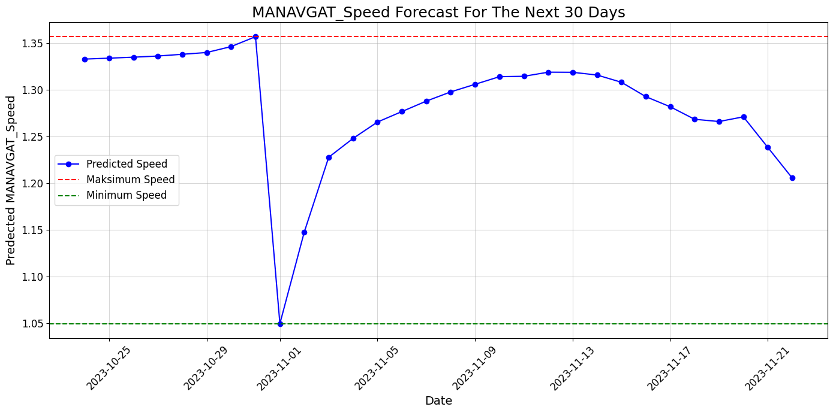
Once our model is trained, we forecast the data for 30 days after the end of the current date. A 30-day date range was created and then the data for future dates was normalized to match the model's training data. (Figure 3.3) The graph below is a visualization of the predictions. (Figure3.4)
Figure 3.4

Conclusion
Research of the wind energy capacity of the Manavgat in Turkey was carried out through in-depth statistical analyses, application of machine learning methods and construction of simulations. Our results demonstrated that Manavgat possesses a causal wind energy profile, with certain seasonal wind predominance and average wind speeds set above the low threshold for meaningful efficiency in energy production.
The viability of certain zones for wind turbine erection was further reinforced by the classification and clustering approaches, which also indicated varying wind velocity ranges and inter-regional zones with greater power generating capacities. The artificial neural networks were able to further enhance the simulation undertaken for the district in the word of the future. The mechanical perspective shows the trend of wind velocity changes over time and confirms the reasonableness of a renewable energy program in the area.
By utilizing these results, Manavgat may easily help Turkey’s energy goals, lessen the reliance on countable resources, and allow the country do the best for the sustainable goals. Future work should be devoted to environmental impact assessments and cost-benefit considerations for making wind energy projects more cost efficient in this region.

References

Abu Danish Aiman Bin Abu Sofian, H. R. (2023). Machine learning and the renewable energy revolution: Exploring solar and wind energy solutions for a sustainable future including innovations in energy storage. Sustainable Development.
Enas Taha Sayed, A. G. (2023). Renewable Energy and Energy Storage Systems. MDPI.
Fan Z., L. S. (2023). On the importance of wind turbine wake boundary to wind energy and environmental impact, Energy Conversion and Management.
Karakislak, I. H.-R. (2021). Exploring the interaction between social norms and perceived justice of wind energy projects: A qualitative analysis. Journal of Environmental Policy and Planning.
Kwok K.C.S., H. G. (2023). Wind energy system for buildings in an urban environment. Journal of Wind Engineering and Industrial Aerodynamics.
Olabi, A. G. (2023). Wind energy contribution to the sustainable development goals: Case study on London Array.
Wolniak, R. ,.-Z. (2023). Development of wind energy in EU countries as an alternative resource to fossil fuels in the years 2016–2022.
Alham M.H., Gad M., F., Ibrahim D.K., (2023), Potential of wind energy and economic assessment in Egypt considering optimal hub height by equilibrium optimizer, Ain Shams Engineering Journal,Volume 14,
Kaan M., Bozkurt A., GenÇ M.S.,Genç G.,(2024), Optimization study of an energy storage system supplied solar and wind energy sources for green campus, Process Safety and Environmental Protection, Volume 190,
Jung C., Sanderr L., Scgindler D., (2024), Future global offshore wind energy under climate change and advanced wind turbine technology, Energy Conversion and Management, Volume 321,
Akperov M., Eliseev A.V.,Rinke A., Mokhov I.I.,Semenov V.A., Dembitskaya M.,Mathes H., Adakudlu M.,Boberg F., Christense J.H. Dethloff K., Fettweis X.,Gutjahr O., Heinemann G., Koenigk T., Sein D., Laprise R., Mottram R., Nikiema O., Sobolowski S., Zhang W.,(2023), Future projections of wind energy potentials in the arctic for the 21st century under the RCP8.5 scenario from regional climate models, Anthropocene, Volume 44,

