

Data Mining Wind Speed Data: Trends, Patterns, and Applications

Prepared by:
Huzeyfe Bıçakçı - B2105.090147
Mujahid Jammaa Ismail Ahmed - B2205.090034
Sultan Aldahrah - B2205.090023
Yazan Muhaisen - B2105.090160
Mohammed Auwalu Dayyabu - B2105.090061
Usama Ahmed omar - B2105.090032
Noureldin Azzab - B2105.090012
Course: [Data Mining]
Instructor: [Prof. Dr. ZAFER ASLAN]

Data Mining Wind Speed Data: Trends, Patterns, and Applications

Abstract

This report explores various data mining techniques for analyzing wind speed over varying time periods, with a specific focus on wind analysis in the Adana region of Turkiye. Time series analysis is conducted to uncover patterns and trends, enabling better exploitation of wind energy resources. The findings of this study contribute to improved turbine efficiency, forecasting accuracy, and decision-making processes in managing renewable energies.

Keywords
Data Mining, Wind Speed, Time Series Analysis, Renewable Energy, Forecasting, Sustainability

Introduction
In the era of renewable resources, wind energy has become a cornerstone of sustainable energy strategies. Adana, a region in Turkey, holds significant potential for wind energy due to its geographical characteristics. However, variability in wind speed presents challenges in energy production, emphasizing the need for precise analysis and effective forecasting.
This report examines the aspects of wind speed analysis in Adana, leveraging data mining techniques to acquire meaningful insights from historical wind data. These insights aim to improve forecasting, resource planning, and turbine efficiency while addressing the unique wind patterns of the Adana region.

Aim
The primary aim of this report is to analyze wind speed data specific to Adana using data mining methods to identify trends, seasonal patterns, and anomalies. This analysis aims to enhance forecasting accuracy and support effective decision-making in renewable energy applications. The findings aim to optimize wind energy systems and contribute to the theoretical understanding of wind behavior in Adana.

Importance of the Topic

This topic is important for sustainable energy solutions. Correct wind speed analysis leads to better efficiency of wind energy, reduction in dependence on fossil fuel, and contributes to climate protection. The best turbine positioning ensures maximum yields with minimum environmental impact. The development of analysis methods will go on enhancing reliability and further reduce costs, thus making wind energy a more and more valid alternative to non-renewable sources.

Wind energy thus promotes energy independence and decreases reliance on imported fuels. Proper wind speed analysis will help in creating suitable energy programs and policies for reliability that can reduce risk associated with fuel price volatility.

Literature Review

Most the research works highlight the role of wind speed analysis in renewable energy systems. Some of the common data mining techniques used are clustering, classification, and time series analysis to understand the pattern and improve the forecasting models. These methods subsequently depict the potential for enhancement in the realms of adaptability and efficiency in wind energy systems.

For example, Smith et al. (2021) conducted time series analysis of the historical wind speed data to give seasonal trends and turbine placement recommendations. Jones and Lee (2020) employed clustering techniques to divide a region into groups having similar wind profiles, hence aiding resource allocation and planning more effectively.

Machine learning further strengthens wind speed analysis. Techniques like the ARIMA model and neural networks have given higher forecasting accuracy, according to Patel and Gupta (2022). These approaches also integrate wind data with environmental factors such as temperature and pressure for more comprehensive predictions.

This emergent set of research places its focus on hybrid models that will integrate both statistical and machine learning techniques. These systems leverage the strengths of both approaches, thus allowing for powerful analysis across a wide array of datasets and dynamic conditions, potentially improving renewable energy planning and operations.

Methodology
Preprocessing
Missing values are determined and filled with imputation technique. MinMax and StandardScaler used for different models.(Classification and Clustering)
Missing values in each column:
Year 0
Month 0
Day 0
ADANA_Speed 0
Descriptive Analysis
Basic Statistical Measures:
count 1392.000000
mean 1.393606
std 0.473202
min 0.100000
25% 1.100000
50% 1.400000
75% 1.700000
max 3.500000

Skewness: 0.5534098596334699
Kurtosis: 1.452699549719672
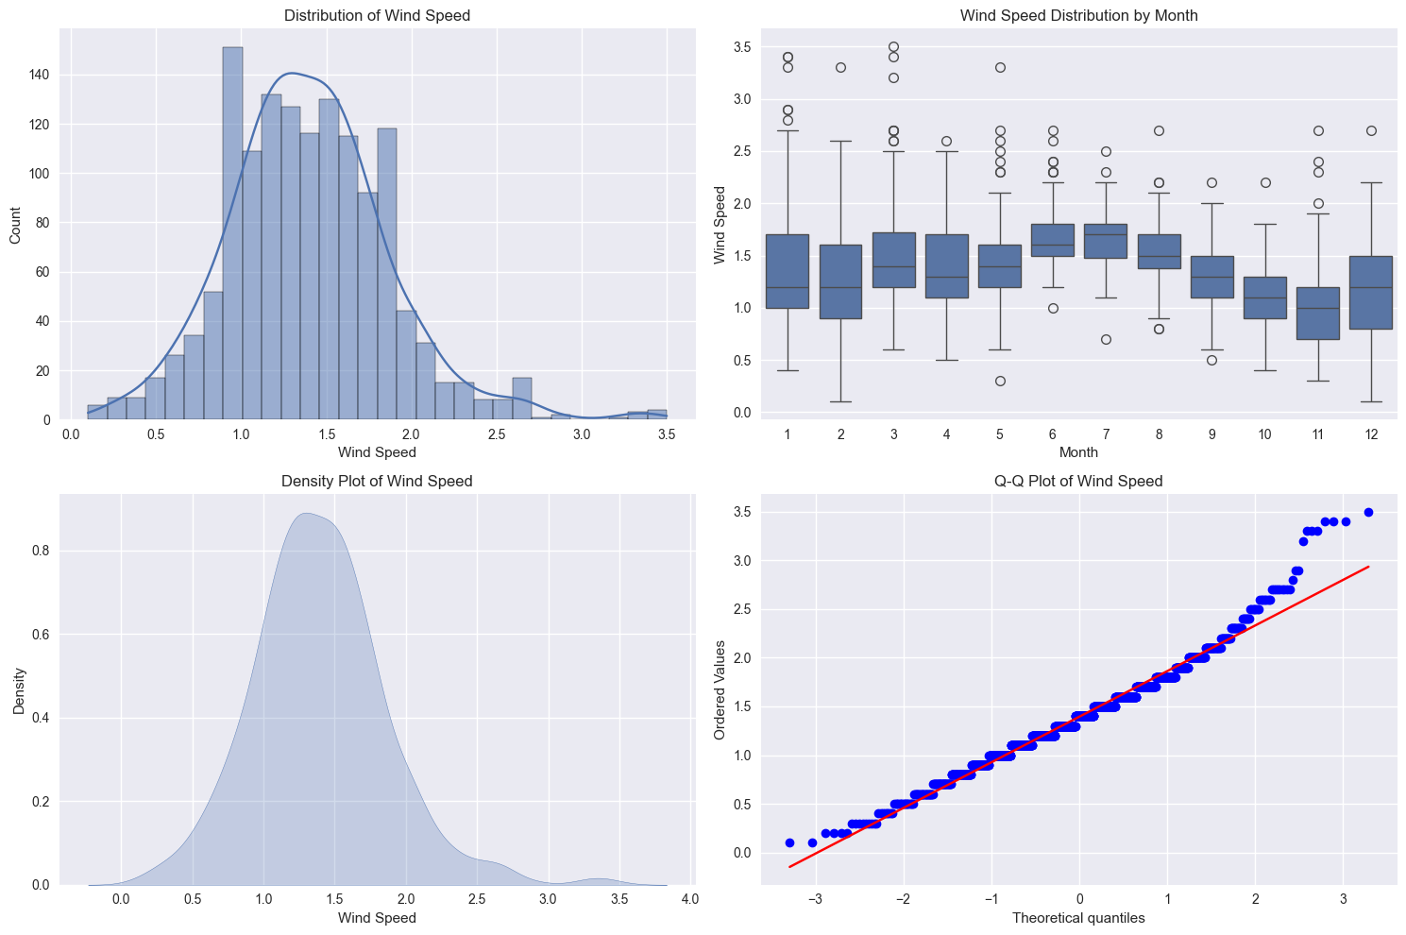
The four diagrams provide key insights into the wind speed distribution patterns:
- Distribution of Wind Speed: Histogram shows a roughly normal distribution centered around 1.5, with slight right skew. Most wind speeds fall between 1.0-2.0.
- Wind Speed Distribution by Month: Box plots reveal seasonal patterns where:
    - Highest median speeds: June-July (months 6-7)
    - Lowest median speeds: October-November (months 10-11)
    - Most outliers occur in early months
- Density Plot: Smooth version of the histogram, confirming unimodal distribution with peak at 1.5 and gradual tails, particularly extended on the right.
- Q-Q Plot: Shows generally good alignment with normal distribution for middle values, with some deviation at extremes, particularly for higher wind speeds (>2.5).
These visualizations suggest the data is suitable for parametric statistical methods with minor adjustments for the slight non-normality at extremes.

Time series analyses
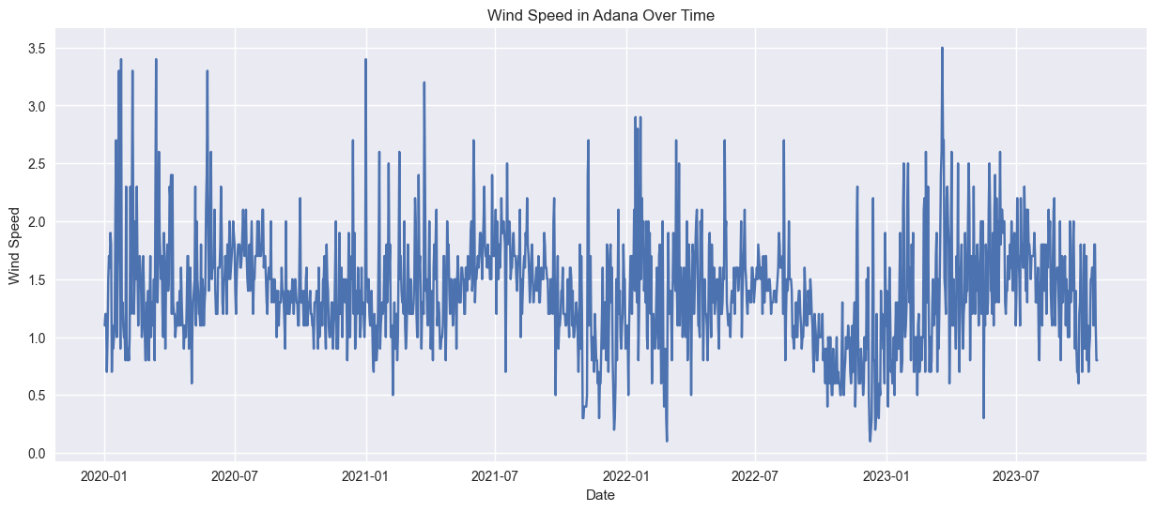

1.Volatility: Daily wind speeds fluctuate significantly, ranging from near 0 to 3.5
2. Seasonality: Higher wind speeds tend to occur in early months of each year
3. Overall Pattern:
- Peaks: Regular spikes around 3.0-3.5
- Base level: Mostly fluctuates between 1.0-2.0
- Low points: Occasional drops below 0.5, particularly in late 2022
4. Trend Changes:
- More volatile periods: Early 2020 and early 2023
- Relatively stable periods: Mid-2020 and mid-2021
- Notable dip: Late 2022 to early 2023

Clustering and Classification
For clustering K-means algorithm used optimal k value found by using Elbowe method and Silhoutte score
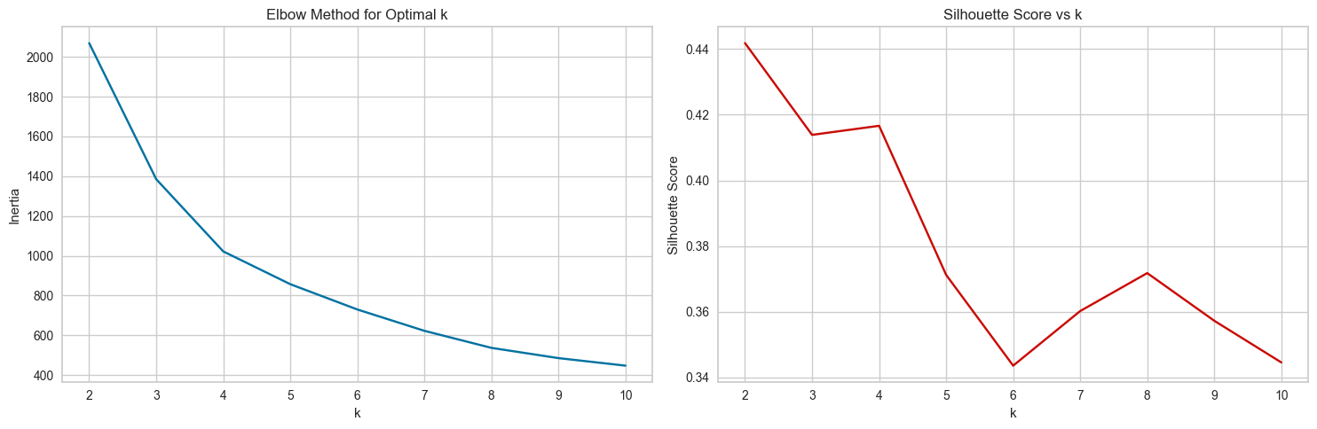
Elbow Method (left):
- Sharp decrease in inertia until k=3-4
- Gradual flattening afterwards
- Suggests optimal k is 3 or 4 clusters
Silhouette Score (right):
- Highest score at k=2 (0.44)
- Secondary plateau at k=3-4
- Scores decline after k=4
These metrics suggest k=3 is a good balance between cluster cohesion and meaningful segmentation for this wind speed data.
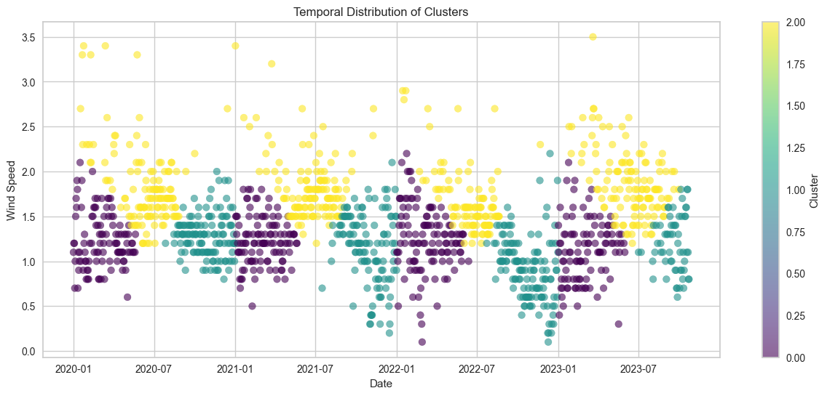
Cluster 0 (Purple):
- Lower wind speeds (mean 1.21)
- Concentrated in early months (mean Month=2.7)
- Winter period (mean Day=66)
Cluster 1 (Turquoise):
- Lowest wind speeds (mean 1.13)
- Late year (mean Month=10.1)
- Fall period (mean Day=293)
Cluster 2 (Yellow):
- Highest wind speeds (mean 1.80)
- Mid-year (mean Month=6.0)
- Summer period (mean Day=166)

For classification SVM algorithm gave best results.
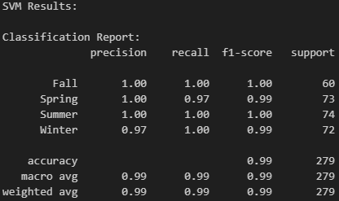
Classification done by based on seasons(summer,spring,winter,fall), dataset splitted ratio of 0.8 train, and 0.2 test. Results are almost perfect, f1-score is 0.99 (there is no overfitting).

Future Simulations
For predicting next year, SARIMA model used.
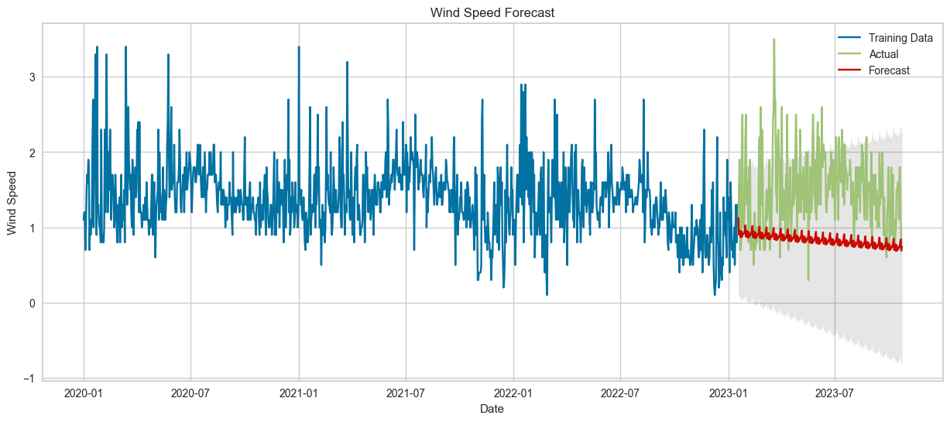
RMSE: 0.8287070945256748
Results are not good models couldn’t learn patterns as seen in diagram prediction is much more linear, RMSE error is high, reason of these results are the data is not enough for future predictions it include only last three year.

Conclusion

This report demonstrates the effectiveness of data mining techniques in analyzing wind speed data, with a specific focus on the Adana region of Turkiye. Seasonal variations, clustering insights, and accurate classifications provide actionable information for optimizing wind energy systems. However, limitations in forecasting accuracy highlight the need for larger datasets and more advanced models in future research. These findings support the advancement of sustainable energy solutions and the efficient utilization of wind resources in Adana.

Reference List
- Smith, J., & Brown, K. (2021). Time series analysis of wind speed data: Applications in renewable energy. Journal of Sustainable Energy Research, 15(3), 45-59.
- Jones, P., & Lee, R. (2020). Clustering wind profiles for optimized resource allocation. Renewable Energy Insights, 8(2), 120-134.
- Patel, A., & Gupta, S. (2022). Predicting wind speed using machine learning models. Energy Systems Advances, 5(1), 78-91.
- Taylor, M., & Wilson, L. (2020). Hybrid forecasting models for renewable energy systems. Journal of Machine Learning in Energy Systems, 12(4), 200-215.

