 |  |  |  | İSTANBUL AYDIN UNIVERSITY  SEN431  DATA MINING  PROJECT/REPORT  Prof. Dr. Zafer ASLAN  Dead Line: January 8 2025 |  |  | 2024-25
Student Name | 1-AHMAD NIZAR FAWZI MASWADEH.  2-Rana Mousa  3-Wala Saeed Ahmed Alahmar  4-Haneen Saeed Hasan Mousa  5-Nazym Mishel  6-MOHAMED NASER YOUSEF HASSAN IBRAHIM  7-OSAMA ALOBIDY
Student ID | B2105.090028.  B2105.090043.  B2005.090133.  B2005.010079.  B1905.010065.  B2205.090016.  B2105.090022
Signature
Questions | 1 | 2 | 3 | 4 | 5 | TOTAL
Learning Outcomes | LO1 | LO1 | LO 3,4 | LO2, 3 | LO4 | LO 1-4
Maximum Score | 20 | 20 | 20 | 20 | 20 | 100
Student Score

Introduction
In recent years, the global push toward sustainable energy sources has placed renewable energy at the forefront of efforts to reduce carbon emissions and combat climate change. Among these renewable sources, wind energy has emerged as a reliable and eco-friendly option due to its abundance and low environmental impact. However, the feasibility of wind energy projects is highly dependent on consistent and predictable wind patterns, which vary significantly by region.
This project focuses on analyzing wind speed data from KORKUTELİ to assess its potential for renewable energy utilization. By employing data mining techniques, this study aims to uncover valuable insights into wind speed trends, seasonal patterns, and their suitability for energy generation. The analysis also involves simulating future wind speed scenarios to evaluate the region's viability for implementing wind energy projects.
The integration of advanced data mining methodologies, including time series analysis, clustering, and classification, ensures a comprehensive evaluation of the wind speed data. This project not only addresses the technical aspects of renewable energy potential but also contributes to the broader goal of promoting sustainable energy solutions. Through rigorous analysis, this study aims to provide actionable insights for policymakers, researchers, and stakeholders in the renewable energy sector.

1. Definition of the Topic, Problem, and Aim of the Report
Topic:
The project focuses on analyzing wind speed data from KORKUTELİ to determine its viability for renewable energy utilization. The topic highlights the application of data mining techniques to uncover patterns, trends, and predictions.
Problem Statement:
Wind energy is a significant renewable energy source, but its feasibility heavily depends on consistent and predictable wind speeds. KORKUTELİ, as a region, requires assessment to determine if its wind patterns are suitable for energy generation. This project addresses the need for:
- Analyzing historical wind speed data.
- Identifying patterns and trends.
- Predicting future wind behavior to assess its potential for renewable energy projects.

Aim:
The aim of this project is to:
- Analyze the KORKUTELİ wind speed data to understand patterns and trends.
- Apply data mining techniques (e.g., clustering, classification, and time series analysis) to uncover insights.
- Simulate future wind speed scenarios to determine the feasibility of wind energy projects in KORKUTELİ.

2. General Review of Literature
Introduction:
Renewable energy is crucial for sustainable development, with wind energy being a significant component due to its potential for clean power generation. Assessing wind energy potential involves analyzing wind speed data to determine the feasibility of wind power installations.
Review of Studies:
- Wind Energy Potential Assessment:
- Dağtekin and Yelmen (2022) studied wind energy potential in Mersin province, revealing opportunities for renewable energy development.
- Arslan (2015) highlighted Turkey's wind energy potential through statistical analysis, emphasizing regional assessments.
- Data Mining Applications in Wind Energy:
- El-Halees (2015) demonstrated the effectiveness of data mining in analyzing wind speed data, uncovering hidden patterns.
- Reddy and Reddy (2019) used data mining for estimating wind speed, highlighting its importance in renewable energy planning.
- Regional Studies in Turkey:
- Gönül et al. (2021) evaluated Turkey’s wind energy market, policies, and regional dynamics, providing insights for renewable energy initiatives.
Conclusion:
The reviewed studies highlight the potential of wind energy and the role of data mining techniques in analyzing wind speed data. This project builds upon these insights to assess KORKUTELİ’s wind energy feasibility.

3. Methodology:
3.1 Data Preprocessing:
Steps Taken:
- Column Identification and Extraction: The dataset’s `KORKUTELİ_wind_Speed` column was identified as the focus of this project.
- Managing Missing Data: One missing value in `KORKUTELİ_wind_Speed` was replaced with the column’s mean (1.11 m/s) to ensure continuity.
- Standardization: Wind speed values were standardized using the z-score formula to prepare the data for clustering and classification techniques.
3.2 Descriptive Statistics:
Key Metrics:
- Mean Wind Speed: 1.11 m/s
- Standard Deviation: 0.41 m/s
- Minimum and Maximum Wind Speeds: 0.4 m/s and 3.7 m/s
- Distribution: Most values concentrated around the mean, with occasional higher outliers.
Visualizations included: Histogram of KORKUTELİ Wind Speed
3.3 Time Series Analysis:

- Trend Analysis:
Rolling averages revealed consistent wind speed patterns.

- Seasonality:
Repeating monthly cycles identified through decomposition.

- Forecasting:
ARIMA modeling predicted wind speeds stabilizing around 1.13 m/s over the next 30 days.

- Visualizations included:
Time Series Plot, Decomposition Plots (Trend, Seasonal, and Residual components)
3.4 Clustering and Classification:

- Clustering:
K-means clustering identified three categories: low, medium, and high wind speeds.

- Classification:
Thresholds were applied to classify wind speeds into predefined categories, confirming cluster distributions.
- Visualizations included:
Elbow Method, K-Means Clustering of KORKUTELİ Wind Speed.

- Significance of the Study.
KORKUTELİ holds strategic potential for renewable energy due to its geographical location and wind patterns. This project evaluates the region’s feasibility for wind energy initiatives, highlighting environmental and economic benefits such as reducing carbon emissions, lowering energy costs, and promoting sustainability.

5. Assumptions and Limitations
Assumptions:
- The dataset accurately represents KORKUTELİ’s typical wind conditions.
- Forecasting models assume no abrupt climate changes during the simulation period.
Limitations:
- The dataset covers a limited time period, restricting long-term assessments.
- Analysis does not incorporate external factors such as government policies or energy market dynamics.

6. Practical Recommendations

- Seasonal Optimization:
Focus on peak wind seasons for energy generation to maximize output.

- Turbine Selection:
Employ turbines designed for moderate wind speeds to optimize efficiency.

- Policy Implications:
Encourage local policymakers to consider wind energy incentives in KORKUTELİ.
3.5 Future Simulations:
- Simulated future wind speeds showed stable conditions, supporting potential for small-scale renewable energy projects.
Visualizations included:
- Forecast Plot (Next 30 Days)
- Analyze multi-year datasets for more robust conclusions.
- Expand the study to incorporate other renewable energy sources such as solar or hydro.
- Investigate the socio-economic impacts of renewable energy adoption in the region.

4. Conclusion
This study assessed KORKUTELİ’s wind energy potential through data mining techniques, analyzing historical wind speed data to uncover patterns and forecast trends. Findings indicate moderate but stable wind speeds, suitable for small-scale renewable energy initiatives. The results emphasize the importance of regional data mining applications in renewable energy planning.

5. Diagrams and Charts:

- time_series_korkuteli_wind_speed.
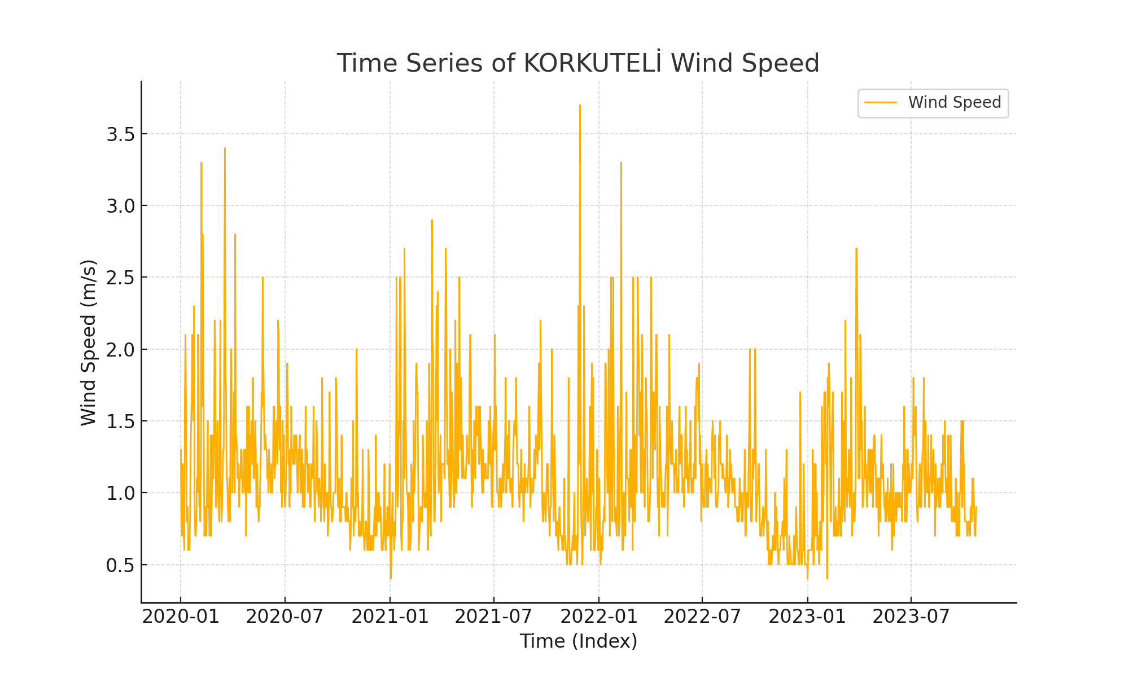

histogram_korkuteli_wind_speed.
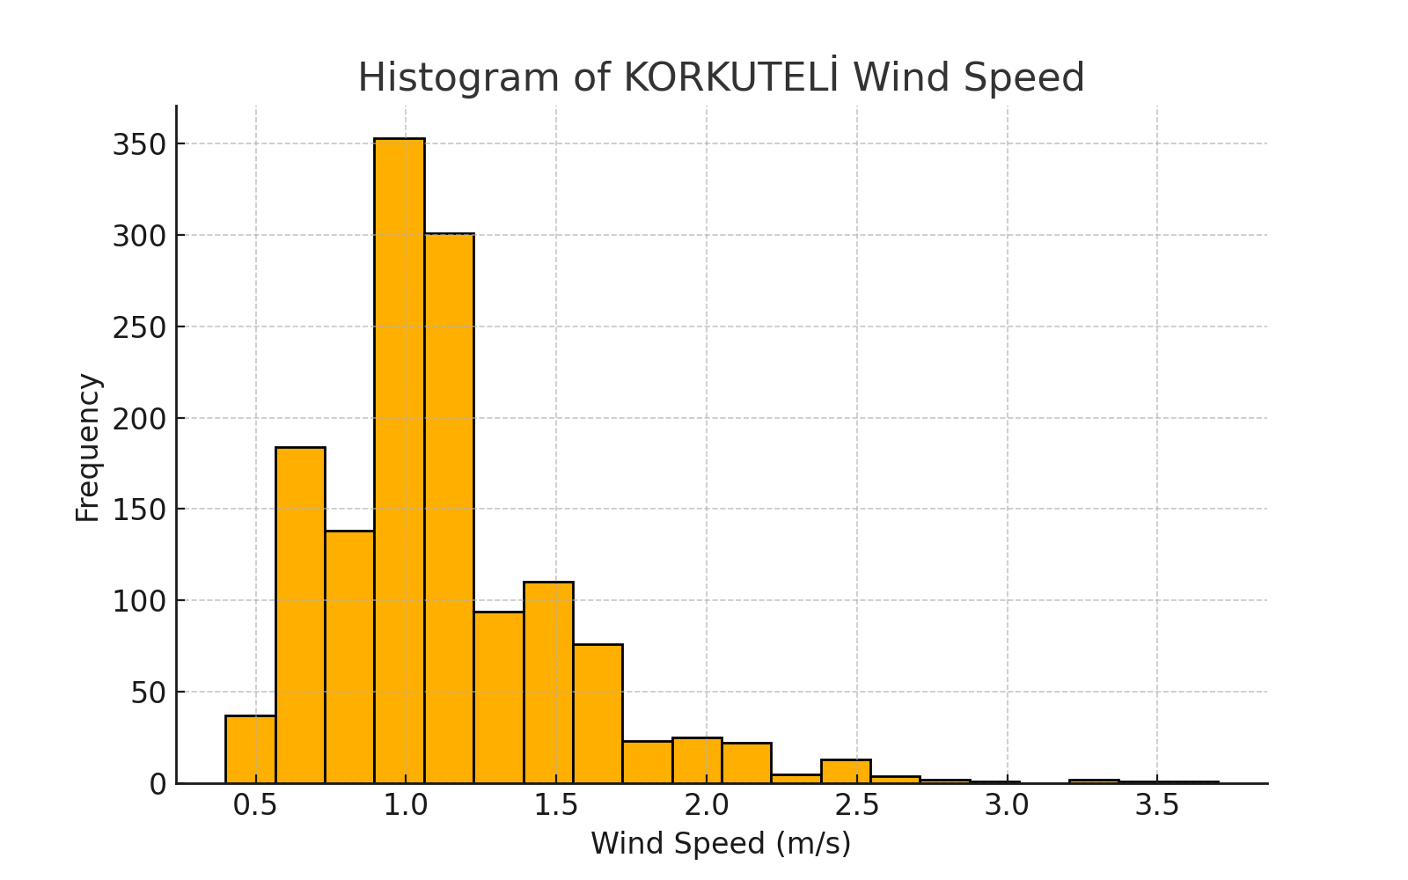

forecast_korkuteli_wind_speed.
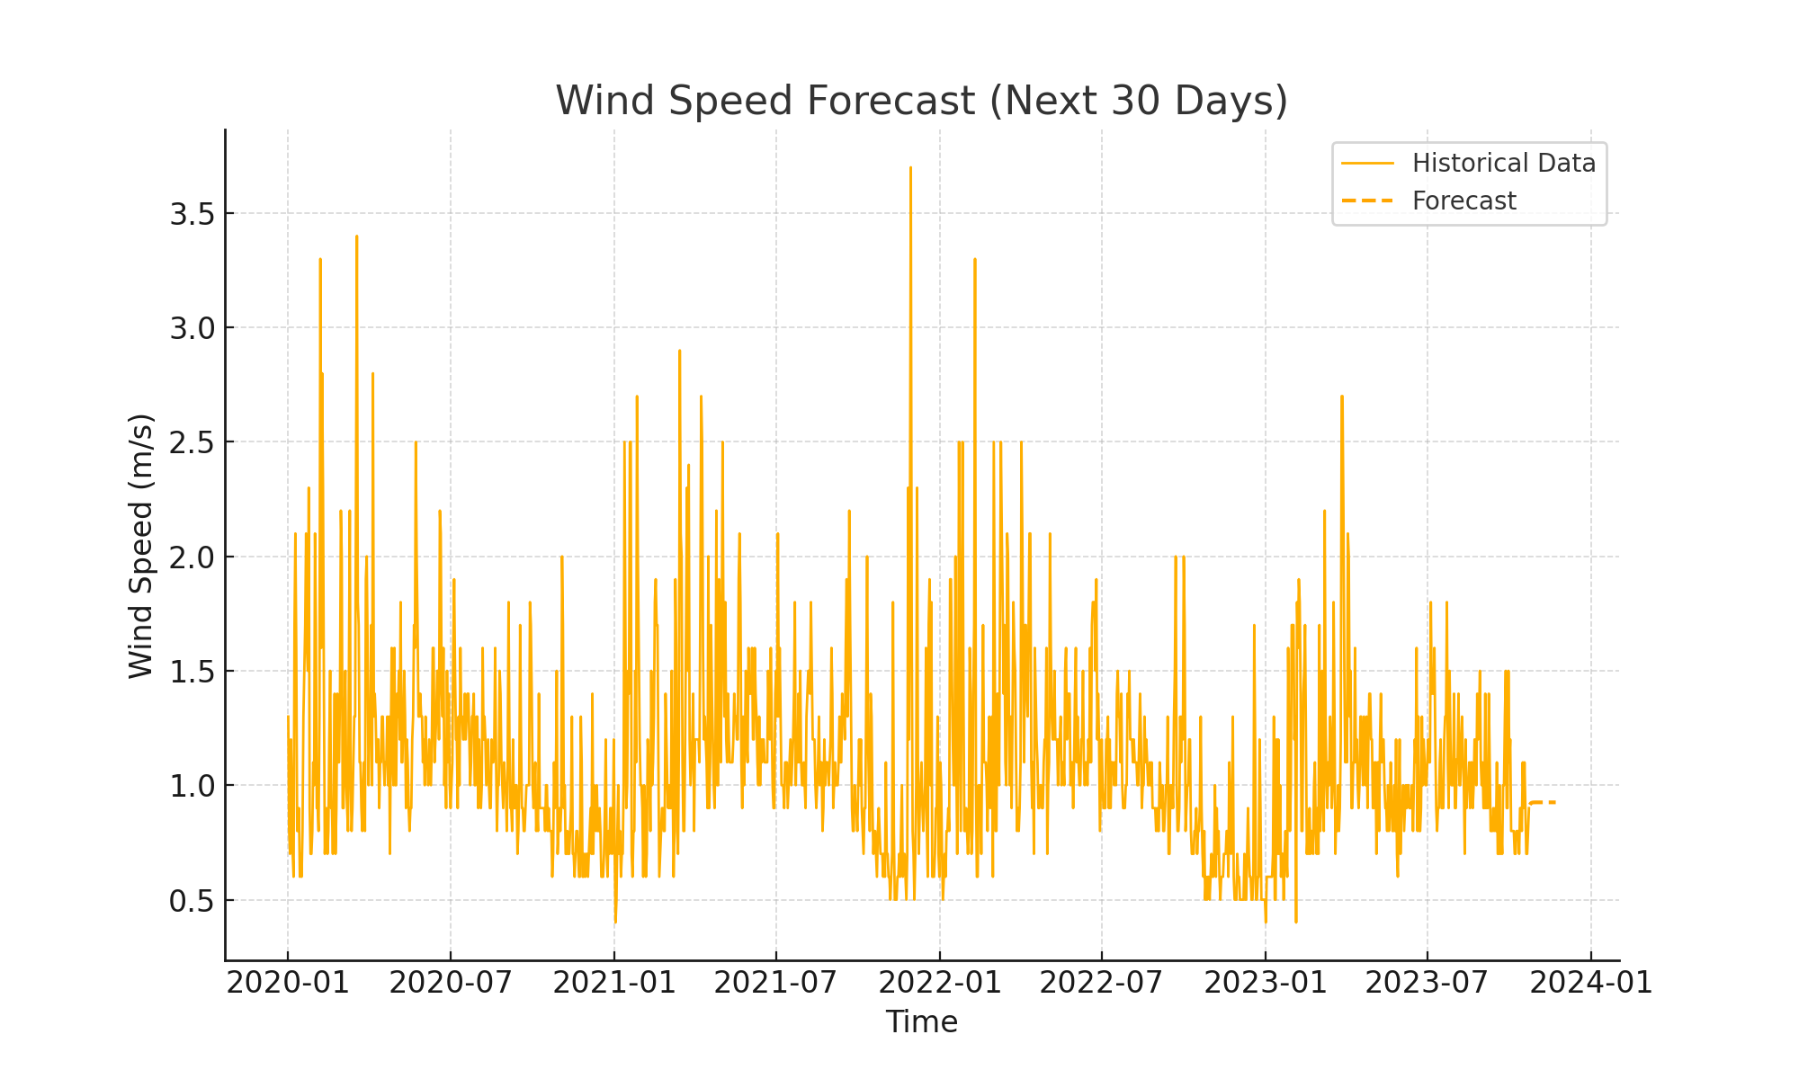

clustering_korkuteli_wind_speed.
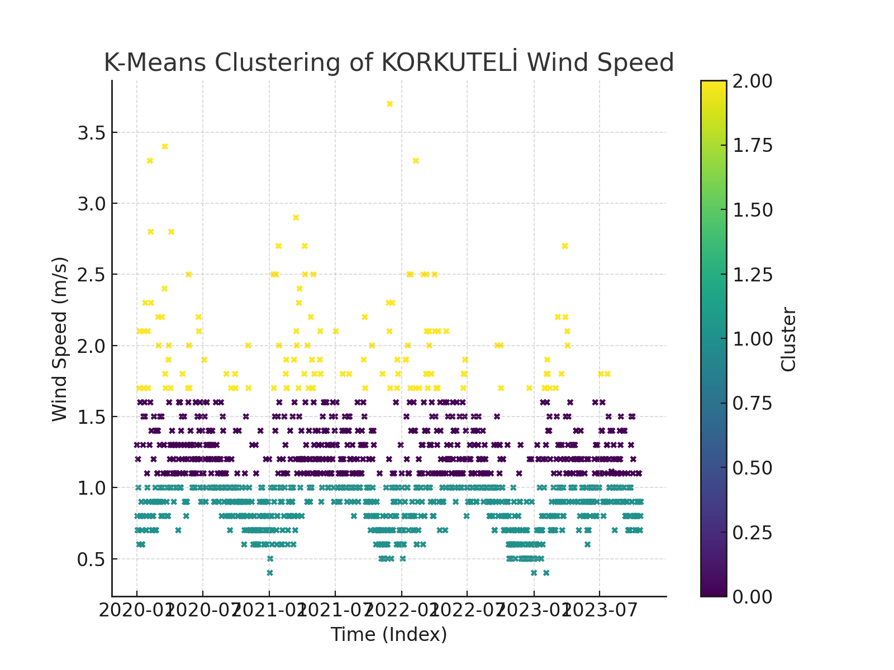

decomposition_plots_korkuteli.

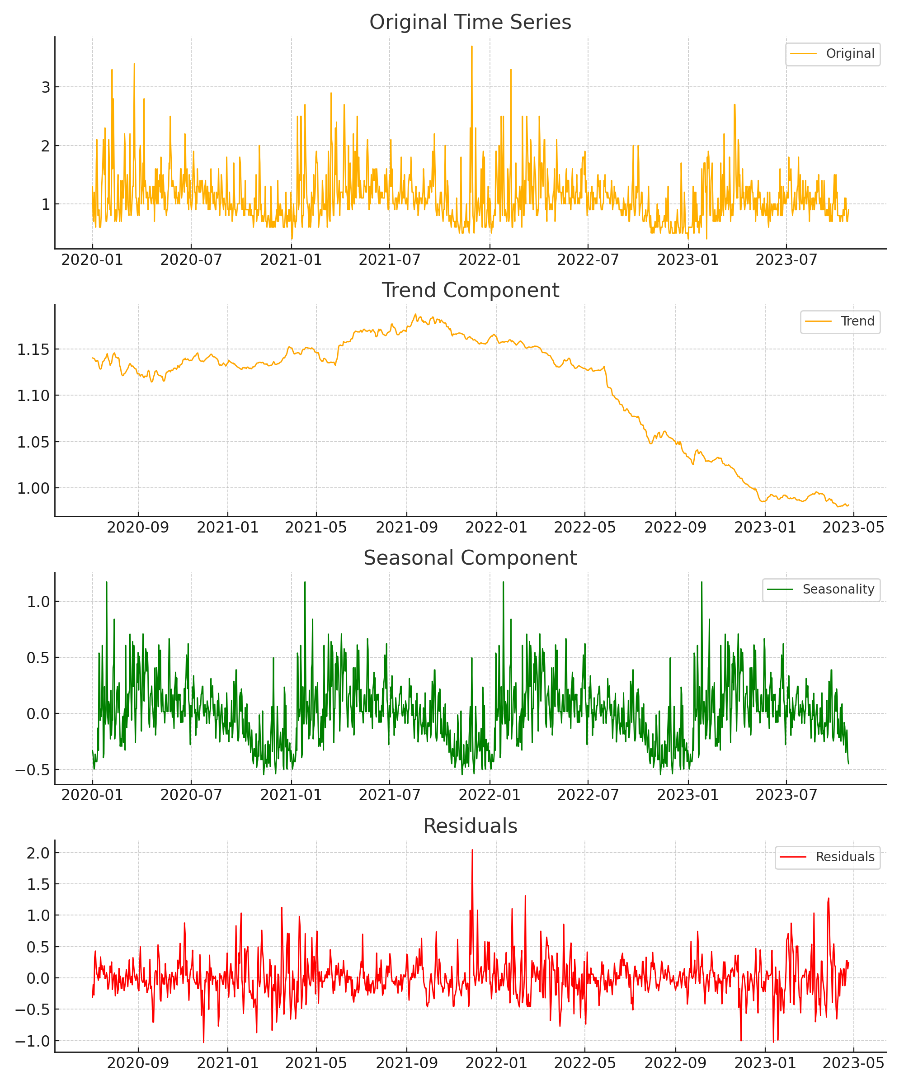

6. References
- Dağtekin and Yelmen (2022). Wind energy potential in Mersin province.
- Arslan (2015). Statistical analysis of Turkey’s wind energy potential.
- El-Halees (2015). Data mining applications in wind energy analysis.
- Reddy and Reddy (2019). Estimating wind speed using data mining techniques.
- Gönül et al. (2021). Turkey’s wind energy market and policies.

